**Q-1. Write an SQL query to fetch “FIRST\_NAME” from Worker table using the alias name as <WORKER\_NAME>.**

**Ans.**

The required query is:

Select FIRST\_NAME AS WORKER\_NAME from Worker;

**Q-2. Write an SQL query to fetch “FIRST\_NAME” from Worker table in upper case.**

**Ans.**

The required query is:

Select upper(FIRST\_NAME) from Worker;

**Q-3. Write an SQL query to fetch unique values of DEPARTMENT from Worker table.**

**Ans.**

The required query is:

Select distinct DEPARTMENT from Worker;

**Q-4. Write an SQL query to print the first three characters of  FIRST\_NAME from Worker table.**

**Ans.**

The required query is:

Select substring(FIRST\_NAME,1,3) from Worker;

**Q-5. Write an SQL query to find the position of the alphabet (‘a’) in the first name column ‘Amitabh’ from Worker table.**

**Ans.**

The required query is:

Select INSTR(FIRST\_NAME, BINARY'a') from Worker where FIRST\_NAME = 'Amitabh';

**Notes.**

* The INSTR method is in case-sensitive by default.
* Using Binary operator will make INSTR work as the case-sensitive function.

**Q-6. Write an SQL query to print the FIRST\_NAME from Worker table after removing white spaces from the right side.**

**Ans.**

The required query is:

Select RTRIM(FIRST\_NAME) from Worker;

**Q-7. Write an SQL query to print the DEPARTMENT from Worker table after removing white spaces from the left side.**

**Ans.**

The required query is:

Select LTRIM(DEPARTMENT) from Worker;

**Q-8. Write an SQL query that fetches the unique values of DEPARTMENT from Worker table and prints its length.**

**Ans.**

The required query is:

Select distinct length(DEPARTMENT) from Worker;

**Q-9. Write an SQL query to print the FIRST\_NAME from Worker table after replacing ‘a’ with ‘A’.**

**Ans.**

The required query is:

Select REPLACE(FIRST\_NAME,'a','A') from Worker;

**Q-10. Write an SQL query to print the FIRST\_NAME and LAST\_NAME from Worker table into a single column COMPLETE\_NAME. A space char should separate them.**

**Ans.**

The required query is:

Select CONCAT(FIRST\_NAME, ' ', LAST\_NAME) AS 'COMPLETE\_NAME' from Worker;

**Q-11. Write an SQL query to print all Worker details from the Worker table order by FIRST\_NAME Ascending.**

**Ans.**

The required query is:

Select \* from Worker order by FIRST\_NAME asc;

**Q-12. Write an SQL query to print all Worker details from the Worker table order by FIRST\_NAME Ascending and DEPARTMENT Descending.**

**Ans.**

The required query is:

Select \* from Worker order by FIRST\_NAME asc,DEPARTMENT desc;

**Q-13. Write an SQL query to print details for Workers with the first name as “Vipul” and “Satish” from Worker table.**

**Ans.**

The required query is:

Select \* from Worker where FIRST\_NAME in ('Vipul','Satish');

**Q-14. Write an SQL query to print details of workers excluding first names, “Vipul” and “Satish” from Worker table.**

**Ans.**

The required query is:

Select \* from Worker where FIRST\_NAME not in ('Vipul','Satish');

**Q-15. Write an SQL query to print details of Workers with DEPARTMENT name as “Admin”.**

**Ans.**

The required query is:

Select \* from Worker where DEPARTMENT like 'Admin%';

**Q-16. Write an SQL query to print details of the Workers whose FIRST\_NAME contains ‘a’.**

**Ans.**

The required query is:

Select \* from Worker where FIRST\_NAME like '%a%';

**Q-17. Write an SQL query to print details of the Workers whose FIRST\_NAME ends with ‘a’.**

**Ans.**

The required query is:

Select \* from Worker where FIRST\_NAME like '%a';

**Q-18. Write an SQL query to print details of the Workers whose FIRST\_NAME ends with ‘h’ and contains six alphabets.**

**Ans.**

The required query is:

Select \* from Worker where FIRST\_NAME like '\_\_\_\_\_h';

**Q-19. Write an SQL query to print details of the Workers whose SALARY lies between 100000 and 500000.**

**Ans.**

The required query is:

Select \* from Worker where SALARY between 100000 and 500000;

**Q-20. Write an SQL query to print details of the Workers who have joined in Feb’2014.**

**Ans.**

The required query is:

Select \* from Worker where year(JOINING\_DATE) = 2014 and month(JOINING\_DATE) = 2;

**Q-21. Write an SQL query to fetch the count of employees working in the department ‘Admin’.**

**Ans.**

The required query is:

SELECT COUNT(\*) FROM worker WHERE DEPARTMENT = 'Admin';

**Q-22. Write an SQL query to fetch worker names with salaries >= 50000 and <= 100000.**

**Ans.**

The required query is:

SELECT CONCAT(FIRST\_NAME, ' ', LAST\_NAME) As Worker\_Name, Salary

FROM worker

WHERE WORKER\_ID IN

(SELECT WORKER\_ID FROM worker

WHERE Salary BETWEEN 50000 AND 100000);

**Q-23. Write an SQL query to fetch the no. of workers for each department in the descending order.**

**Ans.**

The required query is:

SELECT DEPARTMENT, count(WORKER\_ID) No\_Of\_Workers

FROM worker

GROUP BY DEPARTMENT

ORDER BY No\_Of\_Workers DESC;

**Q-24. Write an SQL query to print details of the Workers who are also Managers.**

**Ans.**

The required query is:

SELECT DISTINCT W.FIRST\_NAME, T.WORKER\_TITLE

FROM Worker W

INNER JOIN Title T

ON W.WORKER\_ID = T.WORKER\_REF\_ID

AND T.WORKER\_TITLE in ('Manager');

**Q-25. Write an SQL query to fetch duplicate records having matching data in some fields of a table.**

**Ans.**

The required query is:

SELECT WORKER\_TITLE, AFFECTED\_FROM, COUNT(\*)

FROM Title

GROUP BY WORKER\_TITLE, AFFECTED\_FROM

HAVING COUNT(\*) > 1;

**Q-26. Write an SQL query to show only odd rows from a table.**

**Ans.**

The required query is:

SELECT \* FROM Worker WHERE MOD (WORKER\_ID, 2) <> 0;

**Q-27. Write an SQL query to show only even rows from a table.**

**Ans.**

The required query is:

SELECT \* FROM Worker WHERE MOD (WORKER\_ID, 2) = 0;

**Q-28. Write an SQL query to clone a new table from another table.**

**Ans.**

The general query to clone a table with data is:

SELECT \* INTO WorkerClone FROM Worker;

The general way to clone a table without information is:

SELECT \* INTO WorkerClone FROM Worker WHERE 1 = 0;

An alternate way to clone a table (for MySQL) without is:

CREATE TABLE WorkerClone LIKE Worker;

**Q-29. Write an SQL query to fetch intersecting records of two tables.**

**Ans.**

The required query is:

(SELECT \* FROM Worker)

INTERSECT

(SELECT \* FROM WorkerClone);

**Q-30. Write an SQL query to show records from one table that another table does not have.**

**Ans.**

The required query is:

SELECT \* FROM Worker

MINUS

SELECT \* FROM Title;

**Q-31. Write an SQL query to show the current date and time.**

**Ans.**

Following MySQL query returns the current date:

SELECT CURDATE();

Following MySQL query returns the current date and time:

SELECT NOW();

Following SQL Server query returns the current date and time:

SELECT getdate();

Following Oracle query returns the current date and time:

SELECT SYSDATE FROM DUAL;

**Q-32. Write an SQL query to show the top n (say 10) records of a table.**

**Ans.**

Following MySQL query will return the top n records using the LIMIT method:

SELECT \* FROM Worker ORDER BY Salary DESC LIMIT 10;

Following SQL Server query will return the top n records using the TOP command:

SELECT TOP 10 \* FROM Worker ORDER BY Salary DESC;

Following Oracle query will return the top n records with the help of ROWNUM:

SELECT \* FROM (SELECT \* FROM Worker ORDER BY Salary DESC)

WHERE ROWNUM <= 10;

**Q-33. Write an SQL query to determine the nth (say n=5) highest salary from a table.**

**Ans.**

The following MySQL query returns the nth highest salary:

SELECT Salary FROM Worker ORDER BY Salary DESC LIMIT n-1,1;

The following SQL Server query returns the nth highest salary:

SELECT TOP 1 Salary

FROM (

SELECT DISTINCT TOP n Salary

FROM Worker

ORDER BY Salary DESC

)

ORDER BY Salary ASC;

**Q-34. Write an SQL query to determine the 5th highest salary without using TOP or limit method.**

**Ans.**

The following query is using the correlated subquery to return the 5th highest salary:

SELECT Salary

FROM Worker W1

WHERE 4 = (

SELECT COUNT( DISTINCT ( W2.Salary ) )

FROM Worker W2

WHERE W2.Salary >= W1.Salary

);

Use the following generic method to find nth highest salary without using TOP or limit.

SELECT Salary

FROM Worker W1

WHERE n-1 = (

SELECT COUNT( DISTINCT ( W2.Salary ) )

FROM Worker W2

WHERE W2.Salary >= W1.Salary

);

**Q-35. Write an SQL query to fetch the list of employees with the same salary.**

**Ans.**

The required query is:

Select distinct W.WORKER\_ID, W.FIRST\_NAME, W.Salary

from Worker W, Worker W1

where W.Salary = W1.Salary

and W.WORKER\_ID != W1.WORKER\_ID;

**Q-36. Write an SQL query to show the second highest salary from a table.**

**Ans.**

The required query is:

Select max(Salary) from Worker

where Salary not in (Select max(Salary) from Worker);

**Q-37. Write an SQL query to show one row twice in results from a table.**

**Ans.**

The required query is:

select FIRST\_NAME, DEPARTMENT from worker W where W.DEPARTMENT='HR'

union all

select FIRST\_NAME, DEPARTMENT from Worker W1 where W1.DEPARTMENT='HR';

**Q-38. Write an SQL query to fetch intersecting records of two tables.**

**Ans.**

The required query is:

(SELECT \* FROM Worker)

INTERSECT

(SELECT \* FROM WorkerClone);

**Q-39. Write an SQL query to fetch the first 50% records from a table.**

**Ans.**

The required query is:

SELECT \*

FROM WORKER

WHERE WORKER\_ID <= (SELECT count(WORKER\_ID)/2 from Worker);

**Q-40. Write an SQL query to fetch the departments that have less than five people in it.**

**Ans.**

The required query is:

SELECT DEPARTMENT, COUNT(WORKER\_ID) as 'Number of Workers' FROM Worker GROUP BY DEPARTMENT HAVING COUNT(WORKER\_ID) < 5;

**Q-41. Write an SQL query to show all departments along with the number of people in there.**

**Ans.**

The following query returns the expected result:

SELECT DEPARTMENT, COUNT(DEPARTMENT) as 'Number of Workers' FROM Worker GROUP BY DEPARTMENT;

**Q-42. Write an SQL query to show the last record from a table.**

**Ans.**

The following query will return the last record from the Worker table:

Select \* from Worker where WORKER\_ID = (SELECT max(WORKER\_ID) from Worker);

**Q-43. Write an SQL query to fetch the first row of a table.**

**Ans.**

The required query is:

Select \* from Worker where WORKER\_ID = (SELECT min(WORKER\_ID) from Worker);

**Q-44. Write an SQL query to fetch the last five records from a table.**

**Ans.**

The required query is:

SELECT \* FROM Worker WHERE WORKER\_ID <=5

UNION

SELECT \* FROM (SELECT \* FROM Worker W order by W.WORKER\_ID DESC) AS W1 WHERE W1.WORKER\_ID <=5;

**Q-45. Write an SQL query to print the name of employees having the highest salary in each department.**

**Ans.**

The required query is:

SELECT t.DEPARTMENT,t.FIRST\_NAME,t.Salary from(SELECT max(Salary) as TotalSalary,DEPARTMENT from Worker group by DEPARTMENT) as TempNew

Inner Join Worker t on TempNew.DEPARTMENT=t.DEPARTMENT

and TempNew.TotalSalary=t.Salary;

**Q-46. Write an SQL query to fetch three max salaries from a table.**

**Ans.**

The required query is:

SELECT distinct Salary from worker a WHERE 3 >= (SELECT count(distinct Salary) from worker b WHERE a.Salary <= b.Salary) order by a.Salary desc;

**Q-47. Write an SQL query to fetch three min salaries from a table.**

**Ans.**

The required query is:

SELECT distinct Salary from worker a WHERE 3 >= (SELECT count(distinct Salary) from worker b WHERE a.Salary >= b.Salary) order by a.Salary desc;

**Q-48. Write an SQL query to fetch nth max salaries from a table.**

**Ans.**

The required query is:

SELECT distinct Salary from worker a WHERE n >= (SELECT count(distinct Salary) from worker b WHERE a.Salary <= b.Salary) order by a.Salary desc;

**Q-49. Write an SQL query to fetch departments along with the total salaries paid for each of them.**

**Ans.**

The required query is:

 SELECT DEPARTMENT, sum(Salary) from worker group by DEPARTMENT;

**Q-50. Write an SQL query to fetch the names of workers who earn the highest salary.**

**Ans.**

The required query is:

SELECT FIRST\_NAME, SALARY from Worker WHERE SALARY=(SELECT max(SALARY) from Worker);

### 1. What is Database?

A database is an organized collection of data, stored and retrieved digitally from a remote or local computer system. Databases can be vast and complex, and such databases are developed using fixed design and modeling approaches.

### 2. What is DBMS?

DBMS stands for Database Management System. DBMS is a system software responsible for the creation, retrieval, updation and management of the database. It ensures that our data is consistent, organized and is easily accessible by serving as an interface between the database and its end users or application softwares.

### 3. What is RDBMS? How is it different from DBMS?

RDBMS stands for Relational Database Management System. The key difference here, compared to DBMS, is that RDBMS stores data in the form of a collection of tables and relations can be defined between the common fields of these tables. Most modern database management systems like MySQL, Microsoft SQL Server, Oracle, IBM DB2 and Amazon Redshift are based on RDBMS.

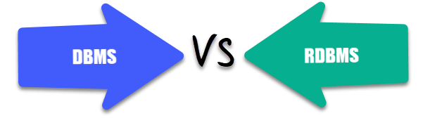

### 4. What is SQL?

SQL stands for Structured Query Language. It is the standard language for relational database management systems. It is especially useful in handling organized data comprised of entities (variables) and relations between different entities of the data.

### 5. What is the difference between SQL and MySQL?

SQL is a standard language for retrieving and manipulating structured databases. On the contrary, MySQL is a relational database management system, like SQL Server, Oracle or IBM DB2, that is used to manage SQL databases.



### 6. What are Tables and Fields?

A table is an organized collection of data stored in the form of rows and columns. Columns can be categorized as vertical and rows as horizontal. The columns in a table are called fields while the rows can be referred to as records.

### 7. What are Constraints in SQL?

Constraints are used to specify the rules concerning data in the table. It can be applied for single or multiple fields in an SQL table during creation of table or after creationg using the ALTER TABLE command. The constraints are:

* **NOT NULL**- Restricts NULL value from being inserted into a column.
* **CHECK**- Verifies that all values in a field satisfy a condition.
* **DEFAULT**- Automatically assigns a default value if no value has been specified for the field.
* **UNIQUE**- Ensures unique values to be inserted into the field.
* **INDEX**- Indexes a field providing faster retrieval of records.
* **PRIMARY KEY**- Uniquely identifies each record in a table.
* **FOREIGN KEY**- Ensures referential integrity for a record in another table.

### 8. What is a Primary Key?

The PRIMARY KEY constraint uniquely identifies each row in a table. It must contain UNIQUE values and has an implicit NOT NULL constraint.  
A table in SQL is strictly restricted to have one and only one primary key, which is comprised of single or multiple fields (columns).

**CREATE** **TABLE** Students ( */\* Create table with a single field as primary key \*/*

ID INT **NOT** **NULL**

Name VARCHAR(255)

**PRIMARY** **KEY** (ID)

);

**CREATE** **TABLE** Students ( */\* Create table with multiple fields as primary key \*/*

ID INT **NOT** **NULL**

LastName VARCHAR(255)

FirstName VARCHAR(255) **NOT** **NULL**,

**CONSTRAINT** PK\_Student

**PRIMARY** **KEY** (ID, FirstName)

);

**ALTER** **TABLE** Students */\* Set a column as primary key \*/*

**ADD** **PRIMARY** **KEY** (ID);

**ALTER** **TABLE** Students */\* Set multiple columns as primary key \*/*

**ADD** **CONSTRAINT** PK\_Student */\*Naming a Primary Key\*/*

**PRIMARY** **KEY** (ID, FirstName);

Q   =>   Write a SQL statement to add PRIMARY KEY 't\_id' to the table 'teachers'.



Q   =>   Write a SQL statement to add primary key constraint 'pk\_a' for table 'table\_a' and fields 'col\_b, col\_c'.



### 9. What is a UNIQUE constraint?

A UNIQUE constraint ensures that all values in a column are different. This provides uniqueness for the column(s) and helps identify each row uniquely. Unlike primary key, there can be multiple unique constraints defined per table. The code syntax for UNIQUE is quite similar to that of PRIMARY KEY and can be used interchangeably.

**CREATE** **TABLE** Students ( */\* Create table with a single field as unique \*/*

ID INT **NOT** **NULL** **UNIQUE**

Name VARCHAR(255)

);

**CREATE** **TABLE** Students ( */\* Create table with multiple fields as unique \*/*

ID INT **NOT** **NULL**

LastName VARCHAR(255)

FirstName VARCHAR(255) **NOT** **NULL**

**CONSTRAINT** PK\_Student

**UNIQUE** (ID, FirstName)

);

**ALTER** **TABLE** Students */\* Set a column as unique \*/*

**ADD** **UNIQUE** (ID);

**ALTER** **TABLE** Students */\* Set multiple columns as unique \*/*

**ADD** **CONSTRAINT** PK\_Student */\* Naming a unique constraint \*/*

**UNIQUE** (ID, FirstName);

### 10. What is a Foreign Key?

A FOREIGN KEY comprises of single or collection of fields in a table that essentially refer to the PRIMARY KEY in another table. Foreign key constraint ensures referential integrity in the relation between two tables.  
The table with the foreign key constraint is labelled as the child table, and the table containing the candidate key is labelled as the referenced or parent table.

**CREATE** **TABLE** Students ( */\* Create table with foreign key - Way 1 \*/*

ID INT **NOT** **NULL**

Name VARCHAR(255)

LibraryID INT

**PRIMARY** **KEY** (ID)

**FOREIGN KEY** (Library\_ID) **REFERENCES** Library(LibraryID)

);

**CREATE** **TABLE** Students ( */\* Create table with foreign key - Way 2 \*/*

ID INT **NOT NULL PRIMARY KEY**

Name VARCHAR(255)

LibraryID INT **FOREIGN KEY** (Library\_ID) **REFERENCES** Library(LibraryID)

);

**ALTER** **TABLE** Students */\* Add a new foreign key \*/*

**ADD** **FOREIGN** **KEY** (LibraryID)

**REFERENCES** Library (LibraryID);

Q   =>   What type of integrity constraint does the foreign key ensure?



Q   =>   Write a SQL statement to add a FOREIGN KEY 'col\_fk' that references 'col\_pk' in 'table\_x'.



### 11. What is a Join? List its different types.

The SQL Join clause is used to combine records (rows) from two or more tables in a SQL database based on a related column between the two.

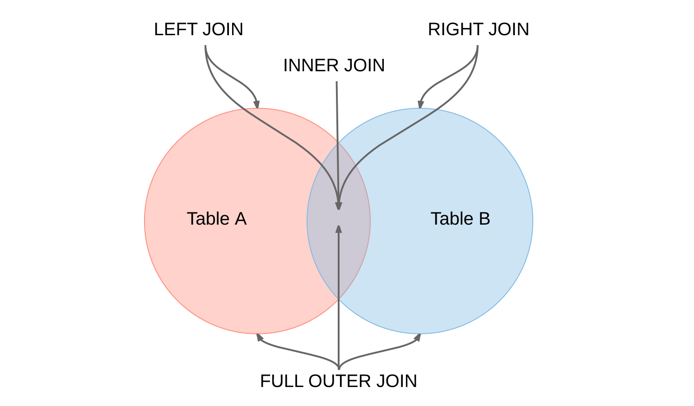

There are four different types of JOINs in SQL:

* **(INNER) JOIN**: Retrieves records that have matching values in both tables involved in the join. This is the widely used join for queries.
* **SELECT** \*
* **FROM** Table\_A
* **JOIN** Table\_B;
* **SELECT** \*
* **FROM** Table\_A
* **INNER JOIN** Table\_B;
* **LEFT (OUTER) JOIN**: Retrieves all the records/rows from the left and the matched records/rows from the right table.
* **SELECT** \*
* **FROM** Table\_A A
* **LEFT JOIN** Table\_B B
* **ON** A.col = B.col;
* **RIGHT (OUTER) JOIN**: Retrieves all the records/rows from the right and the matched records/rows from the left table.
* **SELECT** \*
* **FROM** Table\_A A
* **RIGHT JOIN** Table\_B B
* **ON** A.col = B.col;
* **FULL (OUTER) JOIN**: Retrieves all the records where there is a match in either the left or right table.
* **SELECT** \*
* **FROM** Table\_A A
* **FULL JOIN** Table\_B B
* **ON** A.col = B.col;

### 12. What is a Self-Join?

A **self JOIN**is a case of regular join where a table is joined to itself based on some relation between its own column(s). Self-join uses the INNER JOIN or LEFT JOIN clause and a table alias is used to assign different names to the table within the query.

**SELECT** A.emp\_id **AS** "Emp\_ID",A.emp\_name **AS** "Employee",

B.emp\_id **AS** "Sup\_ID",B.emp\_name **AS** "Supervisor"

**FROM** employee A, employee B

**WHERE** A.emp\_sup = B.emp\_id;

### 13. What is a Cross-Join?

Cross join can be defined as a cartesian product of the two tables included in the join. The table after join contains the same number of rows as in the cross-product of number of rows in the two tables. If a WHERE clause is used in cross join then the query will work like an INNER JOIN.

**SELECT** stu.name, sub.subject

**FROM** students **AS** stu

**CROSS** **JOIN** subjects **AS** sub;

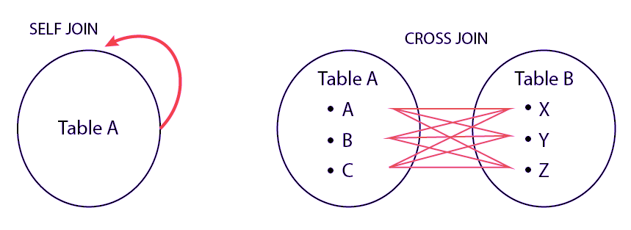

Q   =>   Write a SQL statement to CROSS JOIN 'table\_1' with 'table\_2' and fetch 'col\_1' from table\_1 & 'col\_2' from table\_2 respectively. Do not use alias.



Q   =>   Write a SQL statement to perform SELF JOIN for 'Table\_X' with alias 'Table\_1' and 'Table\_2', on columns 'Col\_1' and 'Col\_2' respectively.



### 14. What is an Index? Explain its different types.

A database index is a data structure that provides quick lookup of data in a column or columns of a table. It enhances the speed of operations accessing data from a database table at the cost of additional writes and memory to maintain the index data structure.

**CREATE** **INDEX** index\_name */\* Create Index \*/*

**ON** table\_name (column\_1, column\_2);

**DROP** **INDEX** index\_name; */\* Drop Index \*/*

There are different types of indexes that can be created for different purposes:

* **Unique and Non-Unique Index**:

Unique indexes are indexes that help maintain data integrity by ensuring that no two rows of data in a table have identical key values. Once a unique index has been defined for a table, uniqueness is enforced whenever keys are added or changed within the index.

**CREATE** **UNIQUE** **INDEX** myIndex

**ON** students (enroll\_no);

Non-unique indexes, on the other hand, are not used to enforce constraints on the tables with which they are associated. Instead, non-unique indexes are used solely to improve query performance by maintaining a sorted order of data values that are used frequently.

* **Clustered and Non-Clustered Index**:

Clustered indexes are indexes whose order of the rows in the database correspond to the order of the rows in the index. This is why only one clustered index can exist in a given table, whereas, multiple non-clustered indexes can exist in the table.

The only difference between clustered and non-clustered indexes is that the database manager attempts to keep the data in the database in the same order as the corresponding keys appear in the clustered index.

Clustering index can improve the performance of most query operations because they provide a linear-access path to data stored in the database.

Q   =>   Write a SQL statement to create a UNIQUE INDEX "my\_index" on "my\_table" for fields "column\_1" & "column\_2".



### 15. What is the difference between Clustered and Non-clustered index?

As explained above, the differences can be broken down into three small factors -

1. Clustered index **modifies the way**records are stored in a database based on the indexed column. Non-clustered index creates a separate entity within the table which references the original table.
2. Clustered index is used for easy and **speedy retrieval**of data from the database, whereas, fetching records from the non-clustered index is relatively slower.
3. In SQL, a table can have **a single**clustered index whereas it can have multiple non-clustered indexes.

### 16. What is Data Integrity?

Data Integrity is the assurance of accuracy and consistency of data over its entire life-cycle, and is a critical aspect to the design, implementation and usage of any system which stores, processes, or retrieves data. It also defines integrity constraints to enforce business rules on the data when it is entered into an application or a database.

### 17. What is a Query?

A query is a request for data or information from a database table or combination of tables. A database query can be either a select query or an action query.

**SELECT** fname, lname */\* select query \*/*

**FROM** myDb.students

**WHERE** student\_id = 1;

**UPDATE** myDB.students */\* action query \*/*

**SET** fname = 'Captain', lname = 'America'

**WHERE** student\_id = 1;

### 18. What is a Subquery? What are its types?

A subquery is a query within another query, also known as **nested query**or **inner query**. It is used to restrict or enhance the data to be queried by the main query, thus restricting or enhancing the output of the main query respectively. For example, here we fetch the contact information for students who have enrolled for the maths subject:

**SELECT** name, email, mob, address

**FROM** myDb.contacts

**WHERE** roll\_no **IN** (

**SELECT** roll\_no

**FROM** myDb.students

**WHERE** subject = 'Maths');

There are two types of subquery - **Correlated** and **Non-Correlated**.

* A **correlated**subquery cannot be considered as an independent query, but it can refer the column in a table listed in the FROM of the main query.
* A **non-correlated**subquery can be considered as an independent query and the output of subquery is substituted in the main query.

Q   =>   Write a SQL query to update the field "status" in table "applications" from 0 to 1.



Q   =>   Write a SQL query to select the field "app\_id" in table "applications" less than 1000.



Q   =>   Write a SQL query to fetch the field "app\_name" from "apps" where "apps.id" is equal to the above collection of "app\_id".



### 19. What is the SELECT statement?

SELECT operator in SQL is used to select data from a database. The data returned is stored in a result table, called the result-set.

**SELECT** \* **FROM** myDB.students;

### 20. What are some common clauses used with SELECT query in SQL?

Some common SQL clauses used in conjuction with a SELECT query are as follows:

* **WHERE** clause in SQL is used to filter records that are necessary, based on specific conditions.
* **ORDER BY** clause in SQL is used to sort the records based on some field(s) in ascending (**ASC**) or descending order (**DESC**).
* **SELECT** \*
* **FROM** myDB.students
* **WHERE** graduation\_year = 2019
* **ORDER** **BY** studentID **DESC**;
* **GROUP BY** clause in SQL is used to group records with identical data and can be used in conjuction with some aggregation functions to produce summarized results from the database.
* **HAVING** clause in SQL is used to filter records in combination with the GROUP BY clause. It is different from WHERE, since WHERE clause cannot filter aggregated records.
* **SELECT** **COUNT**(studentId), country
* **FROM** myDB.students
* **WHERE** country != "INDIA"
* **GROUP** **BY** country
* **HAVING** **COUNT**(studentID) > 5;

### 21. What are UNION, MINUS and INTERSECT commands?

The **UNION**operator combines and returns the result-set retrieved by two or more SELECT statements.  
The **MINUS**operator in SQL is used to remove duplicates from the result-set obtained by the second SELECT query from the result-set obtained by the first SELECT query and then return the filtered results from the first.  
The **INTERSECT**clause in SQL combines the result-set fetched by the two SELECT statements where records from one match the other and then returns this intersection of result-sets.

Certain conditions need to be met before executing either of the above statements in SQL -

* + Each SELECT statement within the clause must have the same number of columns
  + The columns must also have similar data types
  + The columns in each SELECT statement should necessarily have the same order

**SELECT** name **FROM** Students */\* Fetch the union of queries \*/*

**UNION**

**SELECT** name **FROM** Contacts;

**SELECT** name **FROM** Students */\* Fetch the union of queries with duplicates\*/*

**UNION ALL**

**SELECT** name **FROM** Contacts;

**SELECT** name **FROM** Students */\* Fetch names from students \*/*

**MINUS** */\* that aren't present in contacts \*/*

**SELECT** name **FROM** Contacts;

**SELECT** name **FROM** Students */\* Fetch names from students \*/*

**INTERSECT** */\* that are present in contacts as well \*/*

**SELECT** name **FROM** Contacts;

Q   =>   Write a SQL query to fetch "names" that are present in either table "accounts" or in table "registry".



Q   =>   Write a SQL query to fetch "names" that are present in "accounts" but not in table "registry".



Q   =>   Write a SQL query to fetch "names" from table "contacts" that are neither present in "accounts.name" nor in "registry.name".



### 22. What is Cursor? How to use a Cursor?

A database cursor is a control structure that allows for traversal of records in a database. Cursors, in addition, facilitates processing after traversal, such as retrieval, addition and deletion of database records. They can be viewed as a pointer to one row in a set of rows.

#### Working with SQL Cursor

* + **DECLARE** a cursor after any variable declaration. The cursor declaration must always be associated with a SELECT Statement.
  + Open cursor to initialize the result set. The **OPEN** statement must be called before fetching rows from the result set.
  + **FETCH** statement to retrieve and move to the next row in the result set.
  + Call the **CLOSE** statement to deactivate the cursor.
  + Finally use the **DEALLOCATE** statement to delete the cursor definition and release the associated resources.

**DECLARE** @**name** **VARCHAR**(50) */\* Declare All Required Variables \*/*

**DECLARE** db\_cursor **CURSOR** **FOR** */\* Declare Cursor Name\*/*

**SELECT** name

**FROM** myDB.students

**WHERE** parent\_name **IN** ('Sara', 'Ansh')

**OPEN** db\_cursor */\* Open cursor and Fetch data into @name \*/*

**FETCH** next

**FROM** db\_cursor

**INTO** @**name**

**CLOSE** db\_cursor */\* Close the cursor and deallocate the resources \*/*

**DEALLOCATE** db\_cursor

### 23. What are Entities and Relationships?

**Entity**: An entity can be a real-world object, either tangible or intangible, that can be easily identifiable. For example, in a college database, students, professors, workers, departments, and projects can be referred to as entities. Each entity has some associated properties that provide it an identity.

**Relationships**: Relations or links between entities that have something to do with each other. For example - The employees table in a company's database can be associated with the salary table in the same database.

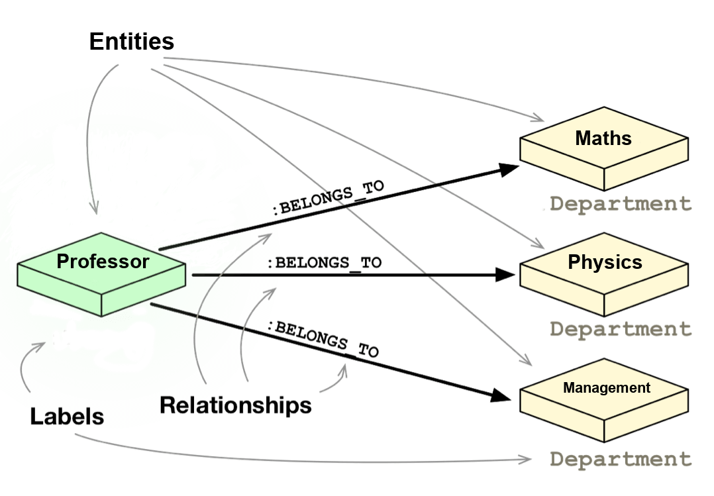

### 24. List the different types of relationships in SQL.

* + **One-to-One** - This can be defined as the relationship between two tables where each record in one table is associated with the maximum of one record in the other table.
  + **One-to-Many** & **Many-to-One** - This is the most commonly used relationship where a record in a table is associated with multiple records in the other table.
  + **Many-to-Many** - This is used in cases when multiple instances on both sides are needed for defining a relationship.
  + **Self Referencing Relationships** - This is used when a table needs to define a relationship with itself.

### 25. What is an Alias in SQL?

An alias is a feature of SQL that is supported by most, if not all, RDBMSs. It is a temporary name assigned to the table or table column for the purpose of a particular SQL query. In addition, aliasing can be employed as an obfuscation technique to secure the real names of database fields. A table alias is also called a **correlation name**.

An alias is represented explicitly by the **AS** keyword but in some cases the same can be performed without it as well. Nevertheless, using the AS keyword is always a good practice.

**SELECT** A.emp\_name **AS** "Employee" */\* Alias using AS keyword \*/*

B.emp\_name **AS** "Supervisor"

**FROM** employee A, employee B */\* Alias without AS keyword \*/*

**WHERE** A.emp\_sup = B.emp\_id;

Q   =>   Write an SQL statement to select all from table "Limited" with alias "Ltd".



### 26. What is a View?

A view in SQL is a virtual table based on the result-set of an SQL statement. A view contains rows and columns, just like a real table. The fields in a view are fields from one or more real tables in the database.

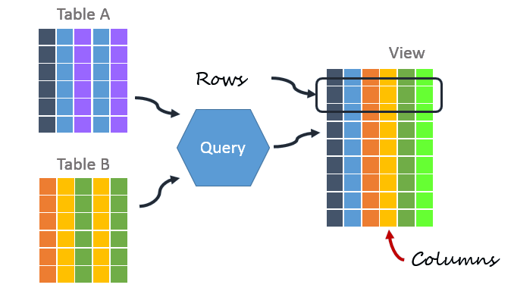

### 27. What is Normalization?

Normalization represents the way of organizing structured data in the database efficiently. It includes creation of tables, establishing relationships between them, and defining rules for those relationships. Inconsistency and redundancy can be kept in check based on these rules, hence, adding flexibility to the database.

### 28. What is Denormalization?

Denormalization is the inverse process of normalization, where the normalized schema is converted into a schema which has redundant information. The performance is improved by using redundancy and keeping the redundant data consistent. The reason for performing denormalization is the overheads produced in query processor by an over-normalized structure.

### 29. What are the various forms of Normalization?

Normal Forms are used to eliminate or reduce redundancy in database tables. The different forms are as follows:

* + **First Normal Form**

A relation is in first normal form if every attribute in that relation is a **single-valued attribute**. If a relation contains composite or multi-valued attribute, it violates the first normal form. Let's consider the following **students** table. Each student in the table, has a name, his/her address and the books they issued from the public library -

#### Students Table

|  |  |  |  |
| --- | --- | --- | --- |
| **Student** | **Address** | **Books Issued** | **Salutation** |
| Sara | Amanora Park Town 94 | Until the Day I Die (Emily Carpenter), Inception (Christopher Nolan) | Ms. |
| Ansh | 62nd Sector A-10 | The Alchemist (Paulo Coelho), Inferno (Dan Brown) | Mr. |
| Sara | 24th Street Park Avenue | Beautiful Bad (Annie Ward), Woman 99 (Greer Macallister) | Mrs. |
| Ansh | Windsor Street 777 | Dracula (Bram Stoker) | Mr. |

As we can observe, the Books Issued field has more than one values per record and to convert it into 1NF, this has to be resolved into separate individual records for each book issued. Check the following table in 1NF form -

#### Students Table (1st Normal Form)

|  |  |  |  |
| --- | --- | --- | --- |
| **Student** | **Address** | **Books Issued** | **Salutation** |
| Sara | Amanora Park Town 94 | Until the Day I Die (Emily Carpenter) | Ms. |
| Sara | Amanora Park Town 94 | Inception (Christopher Nolan) | Ms. |
| Ansh | 62nd Sector A-10 | The Alchemist (Paulo Coelho) | Mr. |
| Ansh | 62nd Sector A-10 | Inferno (Dan Brown) | Mr. |
| Sara | 24th Street Park Avenue | Beautiful Bad (Annie Ward) | Mrs. |
| Sara | 24th Street Park Avenue | Woman 99 (Greer Macallister) | Mrs. |
| Ansh | Windsor Street 777 | Dracula (Bram Stoker) | Mr. |

* + **Second Normal Form**

A relation is in second normal form if it satisfies the conditions for first normal form and does not contain any partial dependency. A relation in 2NF has **no partial dependency**, i.e., it has no non-prime attribute that depends on any proper subset of any candidate key of the table. Often, specifying a single column Primary Key is the solution to the problem. Examples -

* + - **Example 1** - Consider the above example. As we can observe, Students Table in 1NF form has a candidate key in the form of [Student, Address] that can uniquely identify all records in the table. The field Books Issued (non-prime attribute) depends partially on the Student field. Hence, the table is not in 2NF. To convert it into 2nd Normal Form, we will partition the tables into two while specifying a new ***Primary Key*** attribute to identify the individual records in the Students table. The ***Foreign Key*** constraint will be set on the other table to ensure referential integrity.

#### Students Table (2nd Normal Form)

|  |  |  |  |
| --- | --- | --- | --- |
| **Student\_ID** | **Student** | **Address** | **Salutation** |
| 1 | Sara | Amanora Park Town 94 | Ms. |
| 2 | Ansh | 62nd Sector A-10 | Mr. |
| 3 | Sara | 24th Street Park Avenue | Mrs. |
| 4 | Ansh | Windsor Street 777 | Mr. |

#### Books Table (2nd Normal Form)

|  |  |
| --- | --- |
| **Student\_ID** | **Book Issued** |
| 1 | Until the Day I Die (Emily Carpenter) |
| 1 | Inception (Christopher Nolan) |
| 2 | The Alchemist (Paulo Coelho) |
| 2 | Inferno (Dan Brown) |
| 3 | Beautiful Bad (Annie Ward) |
| 3 | Woman 99 (Greer Macallister) |
| 4 | Dracula (Bram Stoker) |

* + - **Example 2** - Consider the following dependencies in relation R(W,X,Y,Z)

WX -> Y [W and X together determine Y]   
 XY -> Z [X and Y together determine Z]

Here, WX is the only candidate key and there is no partial dependency, i.e., any proper subset of WX doesn’t determine any non-prime attribute in the relation.

* + **Third Normal Form**

A relation is said to be in the third normal form, if it satisfies the conditions for second normal form and there is **no transitive dependency** between the non-prime attributes, i.e.,all non-prime attributes are determined only by the candidate keys of the relation and not by any other non-prime attribute.

* + - **Example 1** - Consider the Students Table in the above example. As we can observe, Students Table in 2NF form has a single candidate key Student\_ID (primary key) that can uniquely identify all records in the table. The field Salutation (non-prime attribute), however, depends on the Student Field rather than the candidate key. Hence, the table is not in 3NF. To convert it into 3rd Normal Form, we will once again partition the tables into two while specifying a new ***Foreign Key*** constraint to identify the salutations for individual records in the Students table. The ***Primary Key*** constraint for the same will be set on the Salutations table to identify each record uniquely.

#### Students Table (3rd Normal Form)

|  |  |  |  |
| --- | --- | --- | --- |
| **Student\_ID** | **Student** | **Address** | **Salutation\_ID** |
| 1 | Sara | Amanora Park Town 94 | 1 |
| 2 | Ansh | 62nd Sector A-10 | 2 |
| 3 | Sara | 24th Street Park Avenue | 3 |
| 4 | Ansh | Windsor Street 777 | 1 |

#### Books Table (3rd Normal Form)

|  |  |
| --- | --- |
| **Student\_ID** | **Book Issued** |
| 1 | Until the Day I Die (Emily Carpenter) |
| 1 | Inception (Christopher Nolan) |
| 2 | The Alchemist (Paulo Coelho) |
| 2 | Inferno (Dan Brown) |
| 3 | Beautiful Bad (Annie Ward) |
| 3 | Woman 99 (Greer Macallister) |
| 4 | Dracula (Bram Stoker) |

#### Salutations Table (3rd Normal Form)

|  |  |
| --- | --- |
| **Salutation\_ID** | **Salutation** |
| 1 | Ms. |
| 2 | Mr. |
| 3 | Mrs. |

* + - **Example 2** - Consider the following dependencies in relation R(P,Q,R,S,T)

P -> QR [P together determine C]   
 RS -> T [B and C together determine D]   
 Q -> S   
 T -> P

For the above relation to exist in 3NF, all possible candidate keys in above relation should be {P, RS, QR, T}.

* + **Boyce-Codd Normal Form**

A relation is in Boyce-Codd Normal Form if satisfies the conditions for third normal form and for every functional dependency, Left-Hand-Side is super key. In other words, a relation in BCNF has non-trivial functional dependencies in the form X –> Y, such that X is always a super key. For example - In the above example, Student\_ID serves as the sole unique identifier for the Students Table and Salutation\_ID for the Salutations Table, thus these tables exist in BCNF. Same cannot be said for the Books Table and there can be several books with common Book Names and same Student\_ID.

### 30. What are the TRUNCATE, DELETE and DROP statements?

**DELETE**statement is used to delete rows from a table.

**DELETE** **FROM** Candidates

**WHERE** CandidateId > 1000;

**TRUNCATE**command is used to delete all the rows from the table and free the space containing the table.

**TRUNCATE** **TABLE** Candidates;

**DROP**command is used to remove an object from the database. If you drop a table, all the rows in the table is deleted and the table structure is removed from the database.

**DROP** **TABLE** Candidates;

Q   =>   Write a SQL statement to wipe a table 'Temporary' from memory.



Q   =>   Write a SQL query to remove first 1000 records from table 'Temporary' based on 'id'.



Q   =>   Write a SQL statement to delete the table 'Temporary' while keeping its relations intact.

Check

=> Check result here

### 31. What is the difference between DROP and TRUNCATE statements?

If a table is dropped, all things associated with the tables are dropped as well. This includes - the relationships defined on the table with other tables, the integrity checks and constraints, access privileges and other grants that the table has. To create and use the table again in its original form, all these relations, checks, constraints, privileges and relationships need to be redefined. However, if a table is truncated, none of the above problems exist and the table retains its original structure.

### 32. What is the difference between DELETE and TRUNCATE statements?

The TRUNCATE command is used to delete all the rows from the table and free the space containing the table.  
The DELETE command deletes only the rows from the table based on the condition given in the where clause or deletes all the rows from the table if no condition is specified. But it does not free the space containing the table.

### 33. What are Aggregate and Scalar functions?

An aggregate function performs operations on a collection of values to return a single scalar value. Aggregate functions are often used with the GROUP BY and HAVING clauses of the SELECT statement. Following are the widely used SQL aggregate functions:

* + **AVG()**- Calculates the mean of a collection of values.
  + **COUNT()**- Counts the total number of records in a specific table or view.
  + **MIN()**- Calculates the minimum of a collection of values.
  + **MAX()**- Calculates the maximum of a collection of values.
  + **SUM()**- Calculates the sum of a collection of values.
  + **FIRST()**- Fetches the first element in a collection of values.
  + **LAST()**- Fetches the last element in a collection of values.

*Note: All aggregate functions described above ignore NULL values except for the COUNT function.*

A **scalar function**returns a single value based on the input value. Following are the widely used SQL scalar functions:

* + **LEN()**- Calculates the total length of the given field (column).
  + **UCASE()**- Converts a collection of string values to uppercase characters.
  + **LCASE()**- Converts a collection of string values to lowercase characters.
  + **MID()**- Extracts substrings from a collection of string values in a table.
  + **CONCAT()**- Concatenates two or more strings.
  + **RAND()**- Generates a random collection of numbers of given length.
  + **ROUND()**- Calculates the round off integer value for a numeric field (or decimal point values).
  + **NOW()**- Returns the current data & time.
  + **FORMAT()**- Sets the format to display a collection of values.

### 34. What is User-defined function? What are its various types?

The user-defined functions in SQL are like functions in any other programming language that accept parameters, perform complex calculations, and return a value. They are written to use the logic repetitively whenever required. There are two types of SQL user-defined functions:

* + **Scalar Function**: As explained earlier, user-defined scalar functions return a single scalar value.
  + **Table Valued Functions**: User-defined table-valued functions return a table as output.
    - **Inline**: returns a table data type based on a single SELECT statement.
    - **Multi-statement**: returns a tabular result-set but, unlike inline, multiple SELECT statements can be used inside the function body.

### 35. What is OLTP?

OLTP stands for Online Transaction Processing, is a class of software applications capable of supporting transaction-oriented programs. An essential attribute of an OLTP system is its ability to maintain concurrency. To avoid single points of failure, OLTP systems are often decentralized. These systems are usually designed for a large number of users who conduct short transactions. Database queries are usually simple, require sub-second response times and return relatively few records. Here is an insight into the working of an OLTP system [*Note - The figure is not important for interviews*] -

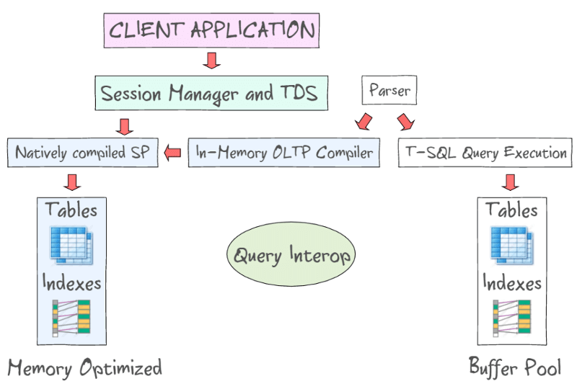

### 36. What are the differences between OLTP and OLAP?

OLTP stands for **Online Transaction Processing**, is a class of software applications capable of supporting transaction-oriented programs. An important attribute of an OLTP system is its ability to maintain concurrency. OLTP systems often follow a decentralized architecture to avoid single points of failure. These systems are generally designed for a large audience of end users who conduct short transactions. Queries involved in such databases are generally simple, need fast response times and return relatively few records. Number of transactions per second acts as an effective measure for such systems.

OLAP stands for **Online Analytical Processing**, a class of software programs which are characterized by relatively low frequency of online transactions. Queries are often too complex and involve a bunch of aggregations. For OLAP systems, the effectiveness measure relies highly on response time. Such systems are widely used for data mining or maintaining aggregated, historical data, usually in multi-dimensional schemas.

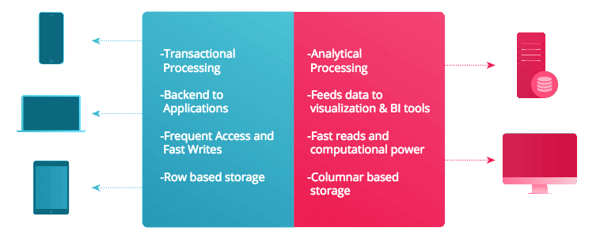

### 37. What is Collation? What are the different types of Collation Sensitivity?

Collation refers to a set of rules that determine how data is sorted and compared. Rules defining the correct character sequence are used to sort the character data. It incorporates options for specifying case-sensitivity, accent marks, kana character types and character width. Below are the different types of collation sensitivity:

* + **Case** sensitivity: **A** and **a** are treated differently.
  + **Accent** sensitivity: **a** and **á** are treated differently.
  + **Kana** sensitivity: Japanese kana characters Hiragana and Katakana are treated differently.
  + **Width** sensitivity: Same character represented in single-byte (half-width) and double-byte (full-width) are treated differently.

### 38. What is a Stored Procedure?

A stored procedure is a subroutine available to applications that access a relational database management system (RDBMS). Such procedures are stored in the database data dictionary. The sole disadvantage of stored procedure is that it can be executed nowhere except in the database and occupies more memory in the database server. It also provides a sense of security and functionality as users who can't access the data directly can be granted access via stored procedures.

**DELIMITER** $$

**CREATE** **PROCEDURE** FetchAllStudents()

**BEGIN**

**SELECT** \* **FROM** myDB.students;

**END** $$

**DELIMITER** ;

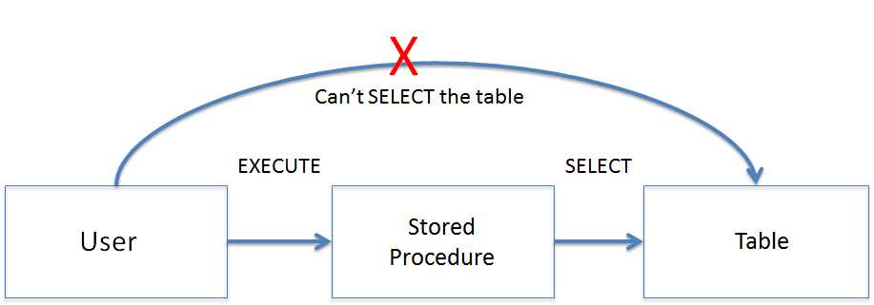

### 39. What is a Recursive Stored Procedure?

A stored procedure which calls itself until a boundary condition is reached, is called a recursive stored procedure. This recursive function helps the programmers to deploy the same set of code several times as and when required. Some SQL programming languages limit the recursion depth to prevent an infinite loop of procedure calls from causing a stack overflow, which slows down the system and may lead to system crashes.

**DELIMITER** $$ */\* Set a new delimiter => $$ \*/*

**CREATE** **PROCEDURE** calctotal( */\* Create the procedure \*/*

**IN** number INT, */\* Set Input and Ouput variables \*/*

**OUT** total INT

) **BEGIN**

**DECLARE** score INT **DEFAULT** **NULL**; */\* Set the default value => "score" \*/*

**SELECT** awards **FROM** achievements */\* Update "score" via SELECT query \*/*

**WHERE** id = number **INTO** score;

**IF** score **IS** **NULL** **THEN** **SET** total = 0; */\* Termination condition \*/*

**ELSE**

**CALL** calctotal(number+1); */\* Recursive call \*/*

**SET** total = total + score; */\* Action after recursion \*/*

**END** IF;

**END** $$ */\* End of procedure \*/*

**DELIMITER** ; */\* Reset the delimiter \*/*

### 40. How to create empty tables with the same structure as another table?

Creating empty tables with the same structure can be done smartly by fetching the records of one table into a new table using the **INTO** operator while fixing a **WHERE** clause to be false for all records. Hence, SQL prepares the new table with a duplicate structure to accept the fetched records but since no records get fetched due to the WHERE clause in action, nothing is inserted into the new table.

**SELECT** \* **INTO** Students\_copy

**FROM** Students **WHERE** 1 = 2;

### 41. What is Pattern Matching in SQL?

SQL pattern matching provides for pattern search in data if you have no clue as to what that word should be. This kind of SQL query uses wildcards to match a string pattern, rather than writing the exact word. The **LIKE** operator is used in conjunction with **SQL Wildcards** to fetch the required information.

* + **Using the % wildcard to perform a simple search**  
    The % wildcard matches zero or more characters of any type and can be used to define wildcards both before and after the pattern. Search a student in your database with first name beginning with the letter K:
  + **SELECT** \*
  + **FROM** students
  + **WHERE** first\_name **LIKE** 'K%'
  + **Omitting the patterns using the NOT keyword**  
    Use the NOT keyword to select records that don't match the pattern. This query returns all students whose first name does not begin with K.
  + **SELECT** \*
  + **FROM** students
  + **WHERE** first\_name **NOT LIKE** 'K%'
  + **Matching a pattern anywhere using the % wildcard twice**  
    Search for a student in the database where he/she has a K in his/her first name.
  + **SELECT** \*
  + **FROM** students
  + **WHERE** first\_name **LIKE** '%Q%'
  + **Using the \_ wildcard to match pattern at a specific position**  
    The \_ wildcard matches exactly one character of any type. It can be used in conjunction with % wildcard. This query fetches all students with letter K at the third position in their first name.
  + **SELECT** \*
  + **FROM** students
  + **WHERE** first\_name **LIKE** '\_\_K%'
  + **Matching patterns for specific length**  
    The \_ wildcard plays an important role as a limitation when it matches exactly one character. It limits the length and position of the matched results. For example -
  + **SELECT** \* */\* Matches first names with three or more letters \*/*
  + **FROM** students
  + **WHERE** first\_name **LIKE** '\_\_\_%'
  + **SELECT** \* */\* Matches first names with exactly four characters \*/*
  + **FROM** students

**WHERE** first\_name **LIKE** '\_\_\_\_'

### **Complex SQL Queries Examples ( 90% ASKED IN Interviews )**

[**1.Query to find Second Highest Salary of Employee?(click for explaination)**](http://www.complexsql.com/query-to-find-second-highest-salary-of-employee/)

**Answer:**

**Select distinct Salary from Employee e1 where 2=Select count(distinct Salary) from Employee e2 where e1.salary<=e2.salary**;

Alternative Solution : Suggested by Ankit Srivastava

**select min(salary)from(select distinct salary from emp order by salary desc)where rownum<=2;**

[**2.Query to find duplicate rows in table?(click here for explaination )**](http://www.complexsql.com/query-to-find-duplicate-records-in-table/)

**Answer :**

**Select \* from Employee a where rowid <>( select max(rowid) from Employee b where a.Employee\_num=b.Employee\_num);**

[**3.How to fetch  monthly Salary of Employee if annual salary is given?(click here for Explaination)**](http://www.complexsql.com/query-find-monthly-salary-employee-annual-salary-given/)

**Answer:**

   Select Employee\_name,Salary/12 as ‘Monthly Salary’ from employee;

[Click here to get information on ROW\_ID](http://www.complexsql.com/rowid-rownum/)

**4.What is the Query to fetch first record from Employee table? (90% asked Complex SQL Queries Examples)**

**Answer:**

 Select \* from Employee where [Rownum](http://www.complexsql.com/rowid-rownum/" \t "_blank)=1;

[Click here to get What is Rownum?](http://www.complexsql.com/rowid-rownum/)

**5.What is the Query to fetch last record from the table?**

**Answer:**

Select \* from Employee where Rowid= select max(Rowid) from Employee;

[](http://www.complexsql.com/complex-sql-queries-examples-with-answers/sqlinterview/)Complex SQL Queries

[Click here to get 20 interview questions on Perforance Tuning..](http://www.complexsql.com/sql-performance-indexing-in-sql-types-of-indexes-in-sql/)

**6.What is Query to display first 5 Records from Employee table?(90% asked Complex SQL Queries Examples)**

**Answer:**

Select \* from Employee where Rownum <= 5;

### 

[CLICK HERE TO GET INFORMATION ON NORMALIZATION](http://www.complexsql.com/database-normalization/)

**6.What is Query to display last 5 Records from Employee table?(90% asked Complex SQL Queries Examples)**

**Answer:**

Select \* from Employee e where rownum <=5

union

select \* from (Select \* from Employee e order by rowid desc) where rownum <=5;

[Click Here to get What is Union?](http://www.complexsql.com/sql-set-operatorsunionunion/)

**7.What is Query to display Nth Record from Employee table?**

**Answer :**

select \* from ( select a.\*, rownum rnum from ( YOUR\_QUERY\_GOES\_HERE — including the order by ) a where rownum <= N\_ROWS ) where rnum >= N\_ROWS

**8.How to get 3 Highest salaries records from Employee table?**

**Answer:**

select distinct salary from employee a where 3 >= (select count(distinct salary) from employee b where a.salary <= b.salary) order by a.salary desc;

Alternative Solution: Suggested by Ankit Srivastava

select min(salary)from(select distinct salary from emp order by salary desc)where rownum<=3;

**9.How to Display**[**Odd[https://i2.wp.com/cdncache-a.akamaihd.net/items/it/img/arrow-10x10.png?resize=10%2C10](https://www.complexsql.com/complex-sql-queries-examples-with-answers/#56367082)**](https://www.complexsql.com/complex-sql-queries-examples-with-answers/#56367082)**rows in Employee table?(90% asked Complex SQL Queries Examples)**

**Answer:**

Select \* from(Select rownum as rno,E.\* from Employee E) where Mod(rno,2)=1;

**10.How to Display Even rows in Employee table?**

**Answer:**

Select \* from(Select rownum as rno,E.\* from Employee) where Mod(rno,2)=0;

### Learn SQL Server Course here: [SQL Server Training](https://mindmajix.com/sql-server-training)

**11.How to fetch 3rd highest salary using Rank Function?**

**Answer:-**

select \* from (Select Dense\_Rank() over ( order by  salary desc) as Rnk,E.\* from Employee E) where Rnk=3;

[Click Here to Get Information on Rank and Dense\_Rank](http://www.complexsql.com/rank-function-in-sql/)

**12.How Can i create table with same structure of Employee table?(90% asked Complex SQL Queries Examples)**

**Answer:**

Create table Employee\_1 as Select \* from Employee where 1=2;

**13.Display first 50% records from Employee table?**

**Answer:**

select rownum, e.\* from emp e where rownum<=(select count(\*)/2 from emp);

**14.Display last 50% records from Employee table?**

**Answer:**

Select rownum,E.\* from Employee E

minus

Select rownum,E.\* from Employee E where rownum<=(Select count(\*)/2) from Employee);

**15.How Can i create table with same structure with data of Employee table?**

**Answer:**

Create table Employee1 as select \* from Employee;

**16.How do i fetch only common records between 2 tables.**

**Answer:**

Select \* from Employee;

Intersect

Select \* from Employee1;

[CLICK HERE TO GET INFORMATION ABOUT INTERSECT OPERATOR](http://www.complexsql.com/sql-set-operators-intersect-minus-real-life-scenarios-difference-between-intersect-and-minus/)

**17.Find Query to get information of Employee where Employee is not assigned to the department**

**Answer:**

Select \* from Employee where Dept\_no Not in(Select Department\_no from Department);

**18.How to get distinct records from the table without using distinct keyword.**

**Answer:**

select \* from Employee a where  rowid = (select max(rowid) from Employee b where  a.Employee\_no=b.Employee\_no);

**19.Select all records from Employee table whose name is ‘Amit’ and ‘Pradnya’**

**Answer:**

Select \* from Employee where Name in(‘Amit’,’Pradnya’);

**20.Select all records from Employee table where name not in ‘Amit’ and ‘Pradnya’**

**Answer:**

select \* from Employee where name Not  in (‘Amit’,’Pradnya’);

[Click Here to get  20 Interview Questions for Tech Mahindra….](http://www.complexsql.com/sql-interview-questions-for-tech-mahindra/)

**21.how to write sql query for the below scenario**  
**I/p:ORACLE**

**O/p:**  
**O  
R  
A  
C  
L  
E  
i.e, splitting into multiple columns a string using sql.**

**Answer:**

Select Substr(‘ORACLE’,Level,1) From Dual  
Connect By Level<= Length(‘ORACLE’);

**22.How to fetch all the records from Employee whose joining year is  2017?**

**Answer:**

Oracle:

select \* from Employee where To\_char(Joining\_date,’YYYY’)=’2017′;

MS SQL:

select \* from Employee where substr(convert(varchar,Joining\_date,103),7,4)=’2017′;

**23.What is SQL Query to find maximum salary of each department?**

**Answer:**

Select Dept\_id,max(salary) from Employee group by Dept\_id;

**24.How Do you find all Employees with its managers?(Consider there is manager id also in Employee table)**

**Answer:**

Select e.employee\_name,m.employee name from Employee e,Employee m where e.Employee\_id=m.Manager\_id;

**25.Display the name of employees who have joined in 2016 and salary is greater than 10000?**

**Answer:**

Select name from Employee where Hire\_Date like ‘2016%’ and salary>10000;

**26.How to display following using query?**

**\***

**\*\***

**\*\*\***

**Answer:**

We cannot use dual table to display output given above. To display output use any table. I am using Student table.

SELECT lpad (‘\*’, ROWNUM,’\*’) FROM Student WHERE ROWNUM <4;

**27.How to add the email validation using only one query?**

**Answer :**

User needs to use [REGEXP\_LIKE function](http://www.complexsql.com/regexp_like-examples/) for email validation.

 SELECT  
Email  
FROM  
Employee  
where NOT REGEXP\_LIKE(Email, ‘[A-Z0-9.\_%+-]+@[A-Z0-9.-]+\.[A-Z]{2,4}’, ‘i’);

**28.How to display 1 to 100 Numbers with query?**

**Answer:**

Select level from dual connect by level <=100;

**Tip:** User needs to know the concept of Hierarchical queries.[Click here to get concept of hierarchical queries](http://www.complexsql.com/hierarchical-queries/)

**29.How to remove duplicate rows from table?(100% asked in Complex SQL Queries for Interviews)**

**Answer:**

**First Step:**Selecting Duplicate rows from table

**Tip:**Use concept of max (rowid) of table. [Click here to get concept of rowid.](http://www.complexsql.com/rowid-rownum/)

Select rollno FROM Student WHERE ROWID <>

(Select max (rowid) from Student b where rollno=b.rollno);

**Step 2:**  Delete duplicate rows

Delete FROM Student WHERE ROWID <>

(Select max (rowid) from Student b where rollno=b.rollno);

**30.How to find count of duplicate rows? (95% asked in SQL queries for Interviews )**

**Answer:**

Select rollno, count (rollno) from Student

Group by rollno

Having count (rollno)>1

Order by count (rollno) desc;

**31.How to Find the Joining date of Employee in YYYY-DAY-Date format.**

Select FIRST\_NAME, to\_char(joining\_date,’YYYY’) JoinYear , to\_char(joining\_date,’Mon’), to\_char(joining\_date,’dd’) from EMPLOYEES;